NEW DIMENSION IN MULTIVARIATE PATTERN RECOGNITION FOR THE APPLICATION IN INDUSTRIAL PROCESS TECHNOLOGY

MOHD ZULI BIN JAAFAR

**COLLEGE OF GRADUATE STUDIES**

**UNIVERSITI TENAGA NASIONAL**

2017

NEW DIMENSION IN MULTIVARIATE PATTERN RECOGNITION FOR THE APPLICATION IN INDUSTRIAL PROCESS TECHNOLOGY

MOHD ZULI BIN JAAFAR

A Thesis Submitted to the College of Graduate Studies, Universiti Tenaga Nasional in Fulfilment of the Requirements for the Degree of

Doctor of Philosophy (Engineering)

AUGUST 2017

DECLARATION

I hereby declare that the thesis is my original work except for quotations and citations which have been duly acknowledged. I also declare that it has not been previously, and is not concurrently submitted for any other degree at Universiti Tenaga Nasional or at any other institutions. This thesis may be made available within the university library and may be photocopied and loaned to other libraries for the purpose of consultation.

_____________SIGN____________

**MOHD ZULI BIN JAAFAR**

Date :

ABSTRACT

Video provides a powerful way to help you prove your point. When you click Online Video, you can paste in the embed code for the video you want to add. You can also type a keyword to search online for the video that best fits your document. To make your document look professionally produced, Word provides header, footer, cover page, and text box designs that complement each other. For example, you can add a matching cover page, header, and sidebar. Click Insert and then choose the elements you want from the different galleries. Themes and styles also help keep your document coordinated. When you click Design and choose a new Theme, the pictures, charts, and SmartArt graphics change to match your new theme. When you apply styles, your headings change to match the new theme. Save time in Word with new buttons that show up where you need them. To change the way a picture fits in your document, click it and a button for layout options appears next to it. When you work on a table, click where you want to add a row or a column, and then click the plus sign. Reading is easier, too, in the new Reading view. You can collapse parts of the document and focus on the text you want. If you need to stop reading before you reach the end, Word remembers where you left off - even on another device. Video provides a powerful way to help you prove your point. When you click Online Video, you can paste in the embed code for the video you want to add. You can also type a keyword to search online for the video that best fits your document. To make your document look professionally produced, Word provides header, footer, cover page, and text box designs that complement each other. For example, you can add a matching cover page, header, and sidebar. Click Insert and then choose the elements you want from the different galleries. Themes and styles also help keep your document coordinated. When you click Design and choose a new Theme, the pictures, charts, and SmartArt graphics change to match your new theme. When you apply styles, your headings change to match the new theme. Save time in Word with new buttons that show up where you need them. To change the way a picture fits in your document, click it and a button for layout options appears next to it. When you work on a table, click where you want to add a row or a column, and then click the plus sign. Reading is easier, too, in the new Reading view. You can collapse parts of the document and focus on the text you want. If you need to stop reading before you reach the end, Word remembers where you left off - even on another device.

ACKNOWLEDGMENT

On the Insert tab, the galleries include items that are designed to coordinate with the overall look of your document. You can use these galleries to insert tables, headers, footers, lists, cover pages, and other document building blocks. When you create pictures, charts, or diagrams, they also coordinate with your current document look.

You can easily change the formatting of selected text in the document text by choosing a look for the selected text from the Quick Styles gallery on the Home tab. You can also format text directly by using the other controls on the Home tab. Most controls offer a choice of using the look from the current theme or using a format that you specify directly.

To change the overall look of your document, choose new Theme elements on the Page Layout tab. To change the looks available in the Quick Style gallery, use the Change Current Quick Style Set command. Both the Themes gallery and the Quick Styles gallery provide reset commands so that you can always restore the look of your document to the original contained in your current template.

DEDICATION

On the Insert tab, the galleries include items with the overall look of your document. You can use these galleries to insert tables, headers, footers, lists, cover pages, and other document building blocks. look.

You can easily change the formatting of selected text in the document text by choosing a look for the selected text from the Quick Styles gallery on the Home tab. You can also format text directly by using the other controls on the Home tab. Most controls offer a choice of using the look from the current theme or using a format that you specify directly.

To change the overall look of your document, choose new Theme elements on the Page Layout tab. To change the looks available in the Quick Style gallery, use the Change Current Quick Style Set command. Both the Themes gallery and the Quick Styles gallery provide reset commands so that you can always restore the look of your document to the original contained in your current template.

TABLE OF CONTENTS

Page

DECLARATION ii

ABSTRACT iii

ACKNOWLEDGMENT iv

DEDICATION v

TABLE OF CONTENTS vi

LIST OF TABLES ix

LIST OF FIGURES x

LIST OF SYMBOLS xi

LIST OF ABBREVIATIONS xii

LIST OF GLOSSARIES xiii

LIST OF PUBLICATIONS xiv

CHAPTER 1 INTRODUCTION 1

1.1 UNITEN Thesis Template2 1

1.2 MZJ Formatting Method 1

1.2.1 Developer Tab 1

1.2.2 Navigation Pane 2

1.2.3 Styles Pane 2

1.3 Video provides a powerful way to help you prove your point. 6

1.3.1 When you click Online Video, you can paste in the embed code for the video you want to add. 6

1.3.2 To make your document look professionally produced, Word provides header, footer, cover page, and text box designs that complement each other. 7

1.4 Caption for Tables 8

CHAPTER 2 LITERATURE REVIEW 12

2.1 Heading 1 12

2.2 Heading 2 12

2.2.1 Heading 3 12

2.2.2 Heading 3a 12

2.2.3 Heading 3b 14

2.3 Other important styles 14

2.4 Equations 17

2.5 Quote 17

CHAPTER 3 MATERIALS AND METHODOLOGY 19

3.1 Introduction 19

3.2 Heading 1 19

3.3 Heading 2 19

3.3.1 Heading 3a 19

3.3.2 Heading 3b 20

3.3.3 Heading 3c 20

3.4 Other important styles 20

3.5 Equations 20

3.6 Quote 21

CHAPTER 4 RESULT AND DISCUSSION 22

4.1 Introduction 22

4.2 Data pre-processing 22

4.2.1 Individual transformation 22

4.2.2 Row scaling 22

4.2.3 Column scaling 22

4.2.4 Mean centring 22

4.2.5 Standardisation 22

4.3 Exploratory data analysis 22

4.4 Variable selection 22

4.4.1 Multiblock methods in chemometrics 23

4.4.2 Multiblock similarity measures 23

CHAPTER 5 CONCLUSION AND RECOMMENDATIONS FOR FUTURE WORK 24

5.1 Introduction 24

5.2 Regression methods 24

5.3 Principal Component Analysis 24

REFERENCES 27

APPENDIX A SAMPLE APPENDIX 1 28

APPENDIX B SAMPLE APPENDIX 2 29

LIST OF TABLES

Table 1.1 Base and supplementary units in SI system. 8

Table 1.2 Derived SI units approved by the International General Conference on Weights and Measures (CGPM). 9

Table 1.3 Derived SI units approved by the International General Conference on Weights and Measures (CGPM). 10

Table 1.4 Sample of new table . 11

Table 2.1 Title 16

Table 2.2 Sample table The text in paragraph can be formatted using *Table text* style. On the other hand, the style for table’s caption is called *Caption for Table UNITEN* 18

Table 3.1 Sample table 21

LIST OF FIGURES

Figure 1.1 MZJ Ideas on formatting 1

Figure 1.2 Enabling the Developer Tab 2

Figure 1.3 Navigation Pane 2

Figure 1.4 Style Pane 3

Figure 1.5 Z Layout 5

Figure 1.6 One dotx for many docx 6

Figure 1.7 Enabling Styles Pane 7

Figure 1.8 Syles Pane on right side of the window 8

Figure 2.1 The RMSE plot for PLS and PCR models by using all descriptors on the three data split methods. 13

Figure 2.2 The atomic packing of a non-dense (random packing) materials. 14

Figure 3.1 Pore size distribution (PSD) of mesoporous materials. 19

LIST OF SYMBOLS

|  |  |
| --- | --- |
| A | Number of PLS or PCA components in the model |
| a | Number of the PLS or PCA component |
| b | PLS regression coefficient |
| b | Number of blocks (b=1,2,3.....,K) |
| C | Coarse APM block |
|  | Pooled covariance matrix for the two classes |
|  |  |
|  |  |
|  |  |
|  |  |
|  |  |
|  |  |
|  |  |
|  |  |
|  |  |
|  |  |
|  |  |
|  |  |

LIST OF ABBREVIATIONS

|  |  |
| --- | --- |
| APM | Airborne particulate matter |
| BBB | blood-brain barrier |
| BMU | Best Matching Unit |
| CMB | Chemical Mass Balance |
| CPCA | Consensus PCA |
| CSI | Class Separation Indices |
| CSM | Class Sample Matrix |
| CSV | Class Sample Vector |
| CWM | Class Weight Matrix |
| CWV | Class Weight Vector |
| EDC | Euclidean Distance to Centriods |

LIST OF GLOSSARIES

|  |  |
| --- | --- |
| APM | Airborne particulate matter |
| BBB | blood-brain barrier |
| BMU | Best Matching Unit |
| CMB | Chemical Mass Balance |
| CPCA | Consensus PCA |
| CSI | Class Separation Indices |
| CSM | Class Sample Matrix |
| CSV | Class Sample Vector |
| CWM | Class Weight Matrix |
| CWV | Class Weight Vector |
| EDC | Euclidean Distance to Centriods |

LIST OF PUBLICATIONS

1. Sim, S.F., T.Y. Ling, S. Lau, and M.Z. Jaafar, A novel computer-aided multivariate water quality index. Environ Monit Assess, 2015. 187(4): p. 181.
2. Yatim, N.N.M., Z.M. Zain, M.Z. Jaafar, Z. Md Yusof, A.R. Laili, M.H. Laili, and M.H. Hisham. Noninvasive glucose level determination using diffuse reflectance near infrared spectroscopy and chemometrics analysis based on in vitro sample and human skin. in Systems, Process and Control (ICSPC), 2014 IEEE Conference on. 2014.
3. Rasaruddin, N.F., M.E.N.M. Ruah, M.N. Hasan, and M.Z. Jaafar, Determination of Iodine Value of Palm Oils Using Partial Least Squares Regression-Fourier Transform Infrared Data. Jurnal Teknologi, 2014. 70(5).
4. Rasaruddin, N.F., M.N. Hasan, M.E.N.M. Ruah, S.S. Fong, and M.Z. Jaafar. Signal processing strategies in FT-NIR and FTIR spectra of palm oils. in Signal Processing & its Applications (CSPA), 2014 IEEE 10th International Colloquium on Signal Processing and its Application 2014. IEEE.
5. Waheed, S., M.Z. Jaafar, N. Siddique, A. Markwitz, and R.G. Brereton, PIXE analysis of PM2. 5 and PM2. 5–10 for air quality assessment of Islamabad, Pakistan: Application of chemometrics for source identification. Journal of Environmental Science and Health, Part A, 2012. 47(13): p. 2016-2027.
6. Ridzuan, M.S.M., M.Z. Jaafar, and M.M. Zain. Quantitative structure-activity relationship (QSAR) modelling of N-aryl derivatives as cholinesterase inhibitors. in Humanities, Science and Engineering Research (SHUSER), 2012 IEEE Symposium on. 2012. IEEE.
7. Jaafar, M.Z., A.H. Khan, S. Adnan, A. Markwitz, N. Siddique, S. Waheed, and R.G. Brereton, Multiblock analysis of environmental measurements: A case study of using Proton Induced X-ray Emission and meteorology dataset obtained from Islamabad Pakistan. Chemometrics and Intelligent Laboratory Systems, 2011. 107(1): p. 31-43.
8. Saim, N., R. Osman, D.R.S.A. Spian, M.Z. Jaafar, H. Juahir, M.P. Abdullah, and F. Ab Ghani, Chemometric approach to validating faecal sterols as source tracer for faecal contamination in water. Water research, 2009. 43(20): p. 5023-5030.

# INTRODUCTION

## UNITEN Thesis Template2

Video provides a powerful way to help you prove your point. When you click Online Video, you can paste in the embed code for the video you want to add. You can also type a keyword to search online for the video that best fits your document.

To make your document look professionally produced, Word provides header, footer, cover page, and text box designs that complement each other. For example, you can add a matching cover page, header, and sidebar.

## MZJ Formatting Method

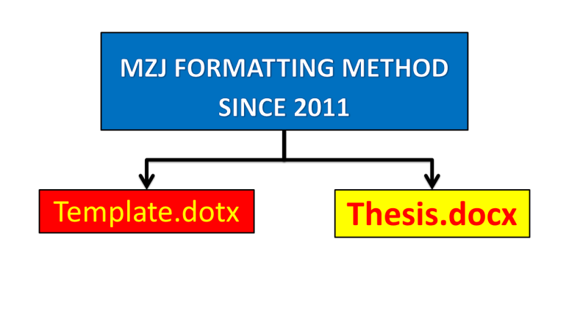

Figure 1.1 MZJ Ideas on formatting

### Developer Tab

To create a new thesis based on this template, just double click the file. A new document will open in Microsoft Word, normally named Untitled.docx. You can start put your content in that file without having to worry about the thesis formatting. However, if you want to apply this dotx template to your current thesis, you need to enable the Developer Tab option. To do so, please refer to Figure 1.2.

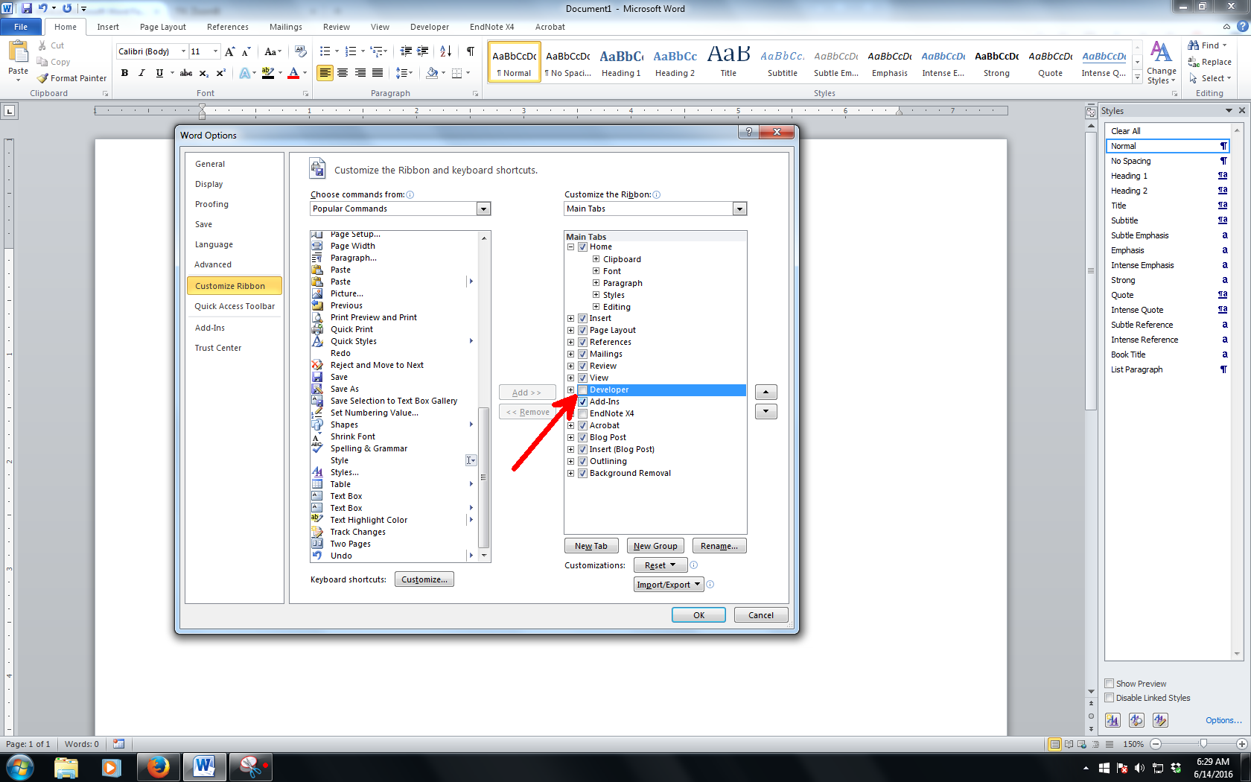

Figure 1.2 Enabling the Developer Tab

Source: Zuli (2016). Use style named *Caption for text in Figure UNITEN* for any text here.

### Navigation Pane

Navigation pane is where you can browse through your thesis based on its heading name. To enable it, please refer to

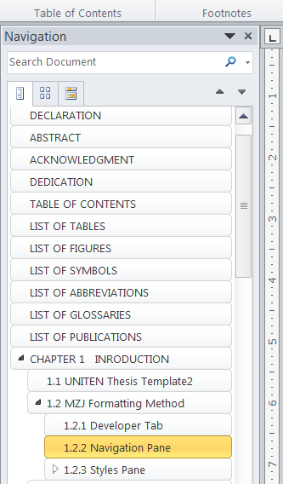

Figure 1.3 Navigation Pane

### Styles Pane

The basic of applying template is using the styles on Style Pane (Figure 1.4). Styles is predefined formatting of text and paragraph. It is most efficient that you put the Styles pane on the right side of the Microsoft Word working environment by click a small arrow as shown in Figure 1.7. If your pane is floating, click and hold the windows and put it at the right side of the windows.

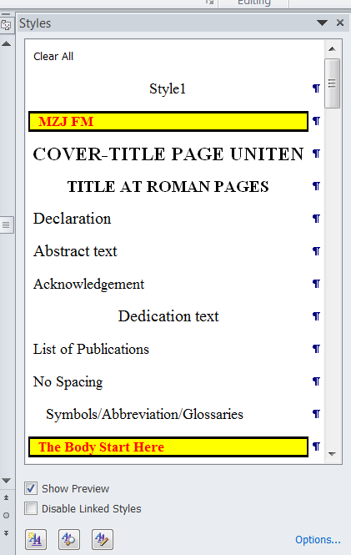

Figure 1.4 Style Pane

#### Quotation

A quotation which is inserted in a sentence must not be more than 40-words long and must always be written within inverted commas.

For example,

According to [4], *“Ethical axioms are found and tested not very differently from the axioms of science. Truth is what stands the test of experience.”*

For a quotation with more than 40 words, use the following style,

“On the Insert tab, the galleries include items that are designed to coordinate with the overall look of your document. You can use these galleries to insert tables, headers, footers, lists, cover pages, and other document building blocks. When you create pictures, charts, or diagrams, they also coordinate with your current document look”

You can easily change the formatting of selected text in the document text by choosing a look for the selected text from the Quick Styles gallery on the Home tab. You can also format text directly by using the other controls on the Home tab. Most controls offer a choice of using the look from the current theme or using a format that you specify directly.

“To change the overall look of your document, choose new Theme elements on the Page Layout tab. To change the looks available in the Quick Style gallery, use the Change Current Quick Style Set command. Both the Themes gallery and the Quick Styles gallery provide reset commands so that you can always restore the look of your document to the original contained in your current template”

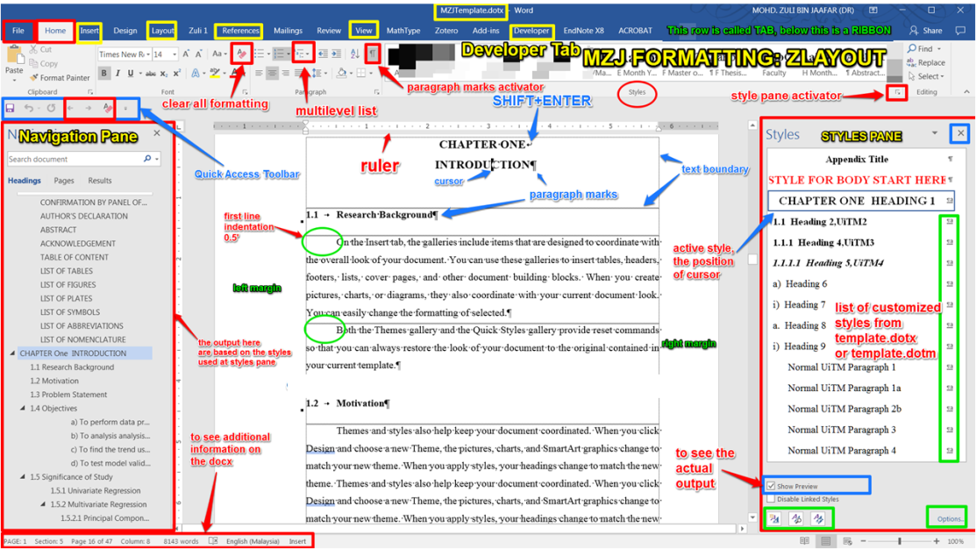

Figure 1.5 Z Layout

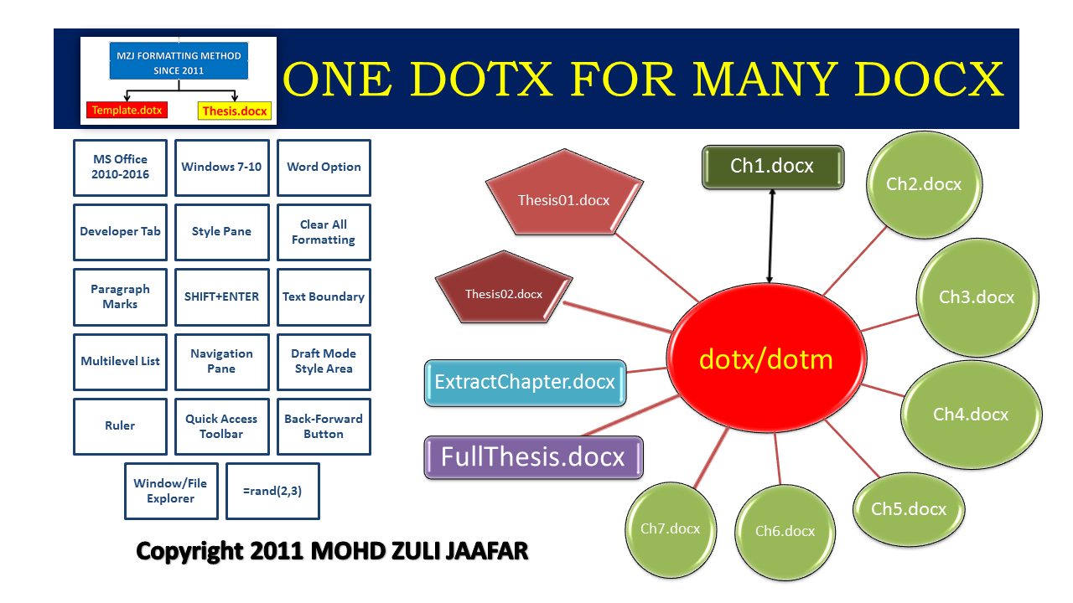

Figure 1.6 One dotx for many docx

## Video provides a powerful way to help you prove your point.

On the Insert tab, the galleries include items that are designed to coordinate with the overall look of your document. You can use these galleries to insert tables, headers, footers, lists, cover pages, and other document building blocks. When you create pictures, charts, or diagrams, they also coordinate with your current document look. You can easily change the formatting of selected text in the document text by choosing a look for the selected text from the Quick Styles gallery on the Home tab.

You can also format text directly by using the other controls on the Home tab. Most controls offer a choice of using the look from the current theme or using a format that you specify directly. To change the overall look of your document, choose new Theme elements on the Page Layout tab. To change the looks available in the Quick Style gallery, use the Change Current Quick Style Set command.

### When you click Online Video, you can paste in the embed code for the video you want to add.

###### Data Pre-processing and Exploratory Analysis by using PCA, SOMs and Class Separation Indices.

###### Multiblock methods and regression analysis of environmental dataset.

###### Pattern recognition in QSAR with the application of SOMs and PLSDA.

###### Data Splitting Methods for Regressions and Classifications.

#### You can also type a keyword to search online for the video that best fits your document.

### To make your document look professionally produced, Word provides header, footer, cover page, and text box designs that complement each other.

For example, you can add a matching cover page, header, and sidebar.

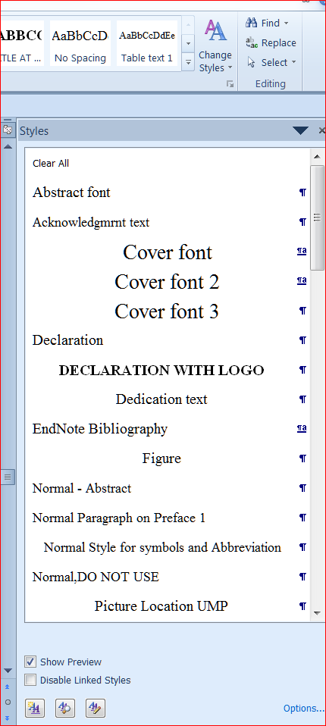

Figure 1.7 Enabling Styles Pane

Once secured on the right side of the working environment, the Styles Pane should look like Figure 1.8.

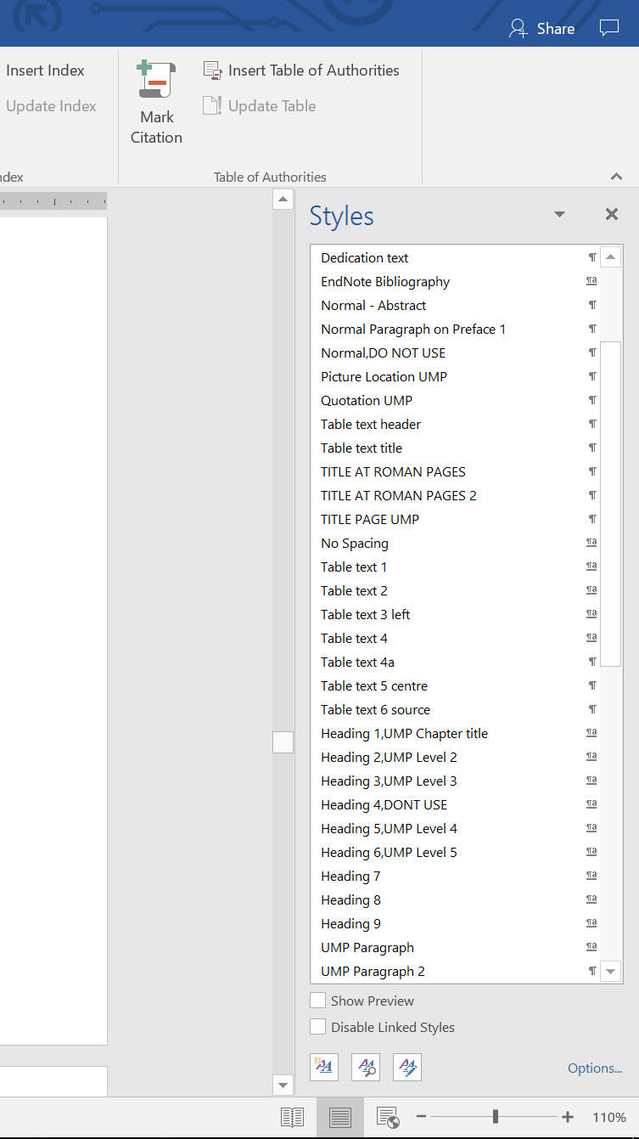

Figure 1.8 Syles Pane on right side of the window

This is just a simulation. Syles Pane on right side of the window Once the PC is ready, you can familiarize yourself with the styles in this template. Some of the styles will be explained in Chapter 2

## Caption for Tables

Once the PC is ready, you can familiarize yourself with the styles in this template. Some of the styles will be explained in Chapter 2.

Table 1.1 Base and supplementary units in SI system.

|  |  |  |  |
| --- | --- | --- | --- |
| **Unit type** | **Quantity** | **Unit name** | **Unit symbol** |
| Base units | Amount of substance | mole | mol |
| Electric current | Ampere | A |
| Length | Meter | M |
| Luminous intensity | Candela | Cd |
| Thermodynamic temperature | Kelvin | K |

Table 1.2Derived SI units approved by the International General Conference on Weights and Measures (CGPM).

|  |  |  |  |
| --- | --- | --- | --- |
| **Quantity** | **Unit name** | **Unit symbol** | **Formula** |
| Absorbed dose | Gray | Gy | J/kg |
| Activity (of a radionuclide) | Becquerel | Bq | 1/s |
| Celsius temperature | Degree Celsius | °C | K |
| Dose equivalent | Sievert | Sv | J/kg |
| Electric capacitance | Farad | F | C/V |
| Electric conductance | Siemens | S | A/V |
| Electric resistance | Ohm | Ω | V/A |
| Electric potential, potential difference, electromotive force | Volt | V | W/A |
| Energy, work, quantity of heat | Joule | J | N•m |
| Force | Newton | N | kg•m/s2 |
| Frequency (of a periodic phenomenon) | Hertz | Hz | 1/s |
| Illuminance | Lux | lx | lm/m2 |
| Inductance | Henry | H | Wb/A |
| Luminous flux | Lumen | lm | cd•sr |
| Magnetic flux | Weber | Wb | V•s |

Table 1.3Derived SI units approved by the International General Conference on Weights and Measures (CGPM).

| Title | Number | Student | Gendet | Income |
| --- | --- | --- | --- | --- |
| Bold |  |  |  |  |
|  |  |  |  |  |
|  |  |  |  |  |
|  |  |  |  |  |
|  |  |  |  |  |
|  |  |  |  |  |
|  |  |  |  |  |
|  |  |  |  |  |
|  |  |  |  |  |
|  |  |  |  |  |
|  |  |  |  |  |
|  |  |  |  |  |
|  |  |  |  |  |
|  |  |  |  |  |
|  |  |  |  |  |
|  |  |  |  |  |
|  |  |  |  |  |
|  |  |  |  |  |
|  |  |  |  |  |
|  |  |  |  |  |
|  |  |  |  |  |
|  |  |  |  |  |
|  |  |  |  |  |
|  |  |  |  |  |
|  |  |  |  |  |
|  |  |  |  |  |
|  |  |  |  |  |
|  |  |  |  |  |
|  |  |  |  |  |
|  |  |  |  |  |
|  |  |  |  |  |
|  |  |  |  |  |
|  |  |  |  |  |
|  |  |  |  |  |
|  |  |  |  |  |
|  |  |  |  |  |
|  |  |  |  |  |
|  |  |  |  |  |
|  |  |  |  |  |
|  |  |  |  |  |
|  |  |  |  |  |
|  |  |  |  |  |
|  |  |  |  |  |
|  |  |  |  |  |
|  |  |  |  |  |
|  |  |  |  |  |
|  |  |  |  |  |
|  |  |  |  |  |
|  |  |  |  |  |
|  |  |  |  |  |

Table 1.4 Sample of new table .

|  |  |  |
| --- | --- | --- |
| No | Item 1 | Item 2 |
| 1 | On the Insert tab, the galleries include items that are designed to coordinate with the overall look of your document. | On the Insert tab, the galleries include items that are designed to coordinate with the overall look of your document. |
| 2 | You can use these galleries to insert tables, headers, footers, lists, cover pages, and other document building blocks. | You can use these galleries to insert tables, headers, footers, lists, cover pages, and other document building blocks. |
| 3 | When you create pictures, charts, or diagrams, they also coordinate with your current document look. | You can easily change the formatting of selected text in the document text by choosing a look for the selected text from the Quick Styles gallery on the Home tab. |

# LITERATURE REVIEW

## Heading 1

Heading 1 is used for chapter naming. In this template, it is called *Heading 1, UNITEN Chapter Title*. In most cases, thesis will have around five to seven chapters.

## Heading 2

The styles used for this subchapter 2.2 is *Heading 2, UNITEN Level 2*.

### Heading 3

The heading for Subchapter 2.2.1 is formatted with *Heading 3, UNITEN Level 3*.

### Heading 3a

Video provides a powerful way to help you prove your point. When you click Online Video, you can paste in the embed code for the video you want to add. You can also type a keyword to search online for the video that best fits your document.

|  |  |  |
| --- | --- | --- |
| 1. PCR models -SPXY | 1. PCR models - KS | 1. PCR-models - Duplex |
| 1. PLS models - SPXY | 1. PLS models - KS | 1. PLS models Duplex |

Figure 2.1 The RMSE plot for PLS and PCR models by using all descriptors on the three data split methods.

### Heading 3b

Video provides a powerful way to help you prove your point. When you click Online Video, you can paste in the embed code for the video you want to add. You can also type a keyword to search online for the video that best fits your document. To make your document look professionally produced, Word provides header, footer, cover page, and text box designs that complement each other. For example, you can add a matching cover page, header, and sidebar.

Click Insert and then choose the elements you want from the different galleries. Themes and styles also help keep your document coordinated. When you click Design and choose a new Theme, the pictures, charts, and SmartArt graphics change to match your new theme. When you apply styles, your headings change to match the new theme. Save time in Word with new buttons that show up where you need them.

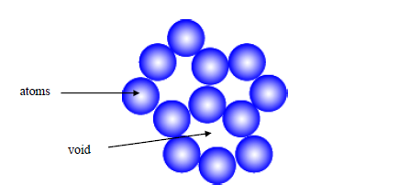

Figure 2.2 The atomic packing of a non-dense (random packing) materials.

#### Heading 4

In this template, Heading 4 is not used. Instead, the heading for level 4 will be using the *Heading 5, UNITEN Level 4*. That is all the heading styles needed to format a thesis.

## Other important styles

All styles developed in this template are essential to a proper thesis formatting. The most widely used style is UNITEN Paragraph. This very paragraph is formatted by *UNITEN Paragraph* s

Table 2.1 Title

|  |  |  |
| --- | --- | --- |
| No | Item | Purpose |
| 1 | PCA biplots | To show the influence of the variables on the samples. This plot is the combination of PCA scores and PCA loadings plot. |
| 2 | Percentage of eigenvalues | To show the importance of each PCs. The percentage gives an indication about the variation of the data explained by each PC. |
| 3 | PCA scores plots | To show the pattern or the distribution of the samples that may exist. |
| 4 | PCA loading plot | To show the pattern or the distribution of the variable that may exist. |
| 5 | 1D of first component scores plot | To support PCA scores plot of the samples’ distribution by using the highest percentage variances explained PCs |

Another important one is the caption styles. All pictures in this template are formatted by using *Caption for Equation* styles.

## Equations

As shown in all equations must be systematically numbered. To insert any equation, copy the whole equation and numbering below and paste on your desired location. After that, edit the equation. The style for equation is *Caption for Equation UNITEN*.

|  |  |
| --- | --- |
|  | (2.1) |

The paragraph after an equation of a figure, has to be formatted in *UNITEN Paragraph 2*. This is to allow some space between the paragraph and the equation or the figure’s caption. This paragraph is using *UNITEN Paragraph 2* style.

## Quote

To insert a quote like this, use *Quotation UNITEN* style. Please ensure all quotation are properly cited.

On the Insert tab, the galleries include items that are designed to coordinate with the overall look of your document. You can use these galleries to insert tables, headers, footers, lists, cover pages, and other document building blocks.

The text in paragraph can be formatted using *Table text* style. On the other hand, the style for table’s caption is called *Caption for Table UNITEN*.

Table 2.2 Sample table The text in paragraph can be formatted using *Table text* style. On the other hand, the style for table’s caption is called *Caption for Table UNITEN*

|  |  |
| --- | --- |
| Test | Text |
| Test | Text |
| Test | Text |
| Test | Text |
| Test | Text |

# MATERIALS AND METHODOLOGY

## Introduction

## Heading 1

Heading 1 is used for chapter naming. In this template, it is called *Heading 1, UNITEN Chapter Title*. In most cases, thesis will have around five to seven chapters.

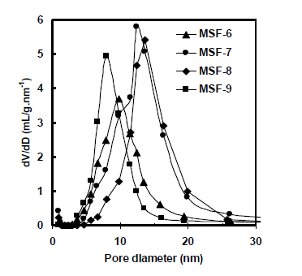

Figure 3.1 Pore size distribution (PSD) of mesoporous materials.

## Heading 2

The styles used for this subchapter 2.2 is *Heading 2, UNITEN Level 2*.

### Heading 3a

The heading for Subchapter 2.2.1 is formatted with *Heading 3, UNITEN Level 3*.

### Heading 3b

### Heading 3c

#### Heading 4

In this template, Heading 4 is not used. Instead, the heading for level 4 will be using the *Heading 5, UNITEN Level 4*. That is all the heading styles needed to format a thesis.

#### Heading 4

In this template, Heading 4 is not used. Instead, the heading for level 4 will be using the *Heading 5, UNITEN Level 4*. That is all the heading styles needed to format a thesis.

## Other important styles

All styles developed in this template are essential to a proper thesis formatting. The most widely used style is UNITEN Paragraph. This very paragraph is formatted by *UNITEN Paragraph* syles.

Another important one is the caption styles. All pictures in this template are formatted by using *Caption for Equation* styles.

## Equations

As shown in Equation 3.1 all equations must be systematically numbered. To insert any equation, copy the whole equation and numbering below and paste on your desired location. After that, edit the equation. The style for equation is *Caption for Equation UMP*.

|  |  |
| --- | --- |
|  | (3.1) |

The paragraph after an equation of a figure, has to be formatted in *UNITEN Paragraph 2*. This is to allow some space between the paragraph and the equation or the figure’s caption. This paragraph is using *UNITEN Paragraph 2* style.

## Quote

To insert a quote like this, use *Quotation UNITEN* style. Please ensure all quotation are properly cited.

On the Insert tab, the galleries include items that are designed to coordinate with the overall look of your document. You can use these galleries to insert tables, headers, footers, lists, cover pages, and other document building blocks.

The text in paragraph can be formatted using *Table text* style. On the other hand, the style for table’s caption is called *Caption for Table UNITEN*.

Table 3.1 Sample table

|  |  |
| --- | --- |
| Test | Text |
| Test | Text |
| Test | Text |
| Test | Text |
| Test | Text |

# RESULT AND DISCUSSION

## Introduction

## Data pre-processing

### Individual transformation

### Row scaling

### Column scaling

### Mean centring

### Standardisation

## Exploratory data analysis

Principal Component Analysis

Self Organizing Maps

Initialisation

Training

Class separation index

Silhouette width

Modified Silhouette width

Regression methods

Multivariate Linear Regression

Principal Components Regression

Partial Least Squares Regression

## Variable selection

### Multiblock methods in chemometrics

### Multiblock similarity measures

#### Multiblock Partial Least Squares Regression

##### Data splitting methods

##### Data splitting for regression

##### Data splitting for classification

Classification methods

Partial Least Squares Discriminant Analysis

Supervised Self Organizing Maps

Data Pre-Processing and Data Drift: Exploratory Analysis and Class Separation Indices

Introduction

Dataset

Airborne particulate matter dataset

Meteorology dataset

QSAR dataset

Chemometrics Methods

Data pre-processing

Principal Component Analysis

Principal Component Regression

Principal Component Analysis, cluster separation indices and data drift

Self Organizing Maps

Results and Discussion

Airborne particulate matter dataset

Sample and elemental analysis

Exploratory data analysis by using Principal Component Analysis and Self Organizing Maps

Data pre-processing, PCA and class separation index

Meteorology dataset

QSAR dataset

# CONCLUSION AND RECOMMENDATIONS FOR FUTURE WORK

## Introduction

On the Insert tab, the galleries include items that are designed to coordinate with the overall look of your document. You can use these galleries to insert tables, headers, footers, lists, cover pages, and other document building blocks. When you create pictures, charts, or diagrams, they also coordinate with your current document look.

You can easily change the formatting of selected text in the document text by choosing a look for the selected text from the Quick Styles gallery on the Home tab. You can also format text directly by using the other controls on the Home tab. Most controls offer a choice of using the look from the current theme or using a format that you specify directly.

To change the overall look of your document, choose new Theme elements on the Page Layout tab. To change the looks available in the Quick Style gallery, use the Change Current Quick Style Set command. Both the Themes gallery and the Quick Styles gallery provide reset commands so that you can always restore the look of your document to the original contained in your current template.

## Regression methods

##### Principal Component Analysis

##### Variable selection

##### PLS and PCR models by using all descriptors

##### Modelling at different empirical significant

##### Classification methods

## Principal Component Analysis

Class Boundary Plot

Percentage Correctly Classified

Conclusions and Future Work

|  |  |  |
| --- | --- | --- |
|  |  |  |
|  |  |  |

REFERENCES

Use reference manager such as Mendeley or Endnote to generate references list here.

APPENDIX A  
SAMPLE APPENDIX 1

For Appendices Heading use TITLE AT ROMAN PAGES style.

APPENDIX B  
SAMPLE APPENDIX 2

For Appendices Heading use TITLE AT ROMAN PAGES style.